AI Attendance Prediction Decision Report
This document demonstrates how an AI model may predict future attendance for a recreational area by analyzing historical trends and environmental variables.

Key Decision Factors Driving Predictions
- Historical Attendance Trends – Past attendance by day, week, month, and season.
- Weather Conditions – Temperature, rain, snow, and severe weather forecasts.
- Holiday and School Break Calendars – Public holidays and vacation periods often increase attendance.
- Special Events – Concerts, tournaments, festivals, and promotional events.
- Local Competition/Events – Nearby attractions or competing events may affect turnout.
- Economic Factors – Ticket pricing, discounts, and promotions.

Historical Data and Forecast Visualization
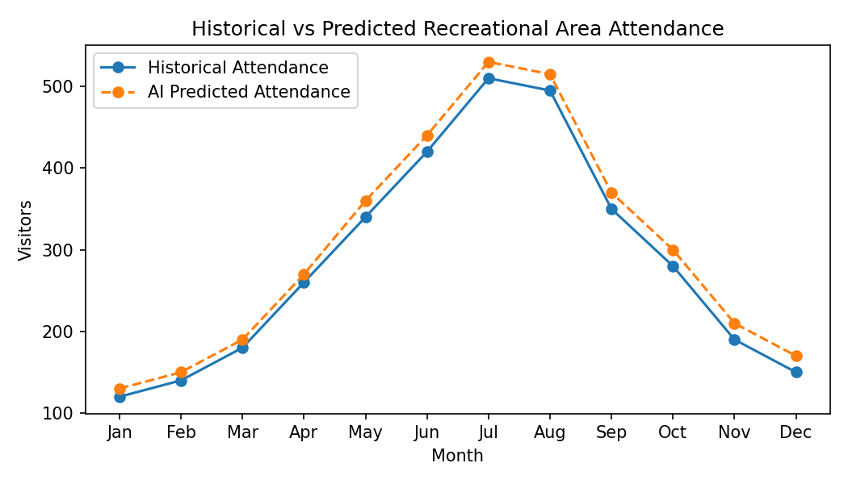

Sample Prediction Confidence Scores
Date | Predicted Attendance | Confidence Score | Likelihood Description
Memorial Day Weekend | 575 | 92% | Very High
Regular Saturday in July | 430 | 88% | High
Rainy Tuesday in October | 160 | 74% | Moderate
Unexpected Heat Wave Event | 310 | 61% | Moderate/Low

How Confidence Scores Work
Confidence scores estimate how certain the AI model is that its prediction will occur based on similarity to past patterns. Higher confidence means the model has seen comparable situations before and believes the prediction is reliable. Lower confidence indicates greater uncertainty due to unusual or less predictable conditions.

